An Introduction to Regenerative Injection Therapy (RIT) in Orthopedics
…from a physician’s perspective

Regenerative Injection Therapy (RIT) is an orthopedic approach to healing that is different from traditional orthopedic surgery. Learn about all of the differences between RIT and traditional surgery here.

Disc Bulge
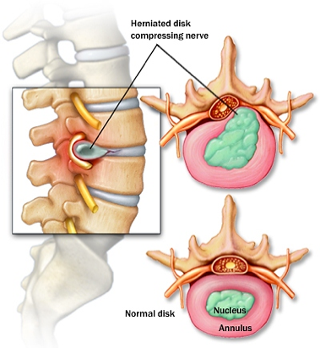
Surgical approach: Is to perform a discectomy (surgically removing the bulge that is pressing on the spinal nerve). The challenge: Discs have a hard time healing because there is such a poor blood supply to the area. Discs get their nutrition via a process called imbibition (similar to osmosis). Cutting out the bulge is like cutting out a snag on a sweater: it weakens the area more…increasing its likelihood of further failure.

The RIT approach: Is to reduce swelling and improve ligamentous integrity by injecting platelet growth factors directly into the affected area, improving the blood supply around the disc. An added step of regenerative injections delivers specially-prepared and cultured CD34 cells (pre-stem cells) into the disc bulge using an ultrasound-guided needle. This treatment strengthens the weakened collagen tissue of the disc precisely at the site of the disc bulge.

Hyperbaric Oxygen: With the injections achieved, how may the tissues be restored to health rapidly? Hyperbaric Oxygen Therapy (HBOT) is a proven treatment strategy that has been developed by the United States Navy. HBOT facilitates wound healing and fights infection through its ability to increase blood flow and carry nutrient-rich oxygenated blood to diseased tissues. Once the patient is exposed to the increased atmospheric pressure and 100% pure oxygen, the body responds by dramatically reducing inflammation. With inflammation reduced, the blood flow increases the delivery of oxygen to deprived tissues. At this point, the healing process accelerates. The body’s natural healing mechanisms can now function efficiently because the damaged tissues are receiving more oxygen. Even when the blood supply has been compromised, tissues can still receive the healing benefits of oxygen from other body fluids and plasma in the surrounding area, such as around the injured discs. These discs benefit from the injection of healing components to the area, and the hyperbaric oxygen accelerates cellular growth and repair.

Joint Replacement
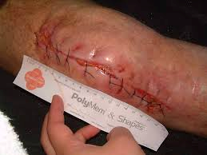
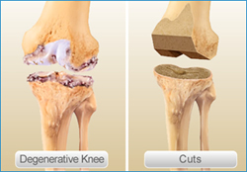
Surgical approach: A total knee replacement (TKR) is a complex procedure requiring the orthopedic surgeon to make precise measurements of the diseased portions of bone, remove the affected bone tissue, and then surgically shave the bone to accommodate the knee implant. During the procedure, the surgeon builds the artificial knee inside the patient’s leg, one component at a time, to create a functional artificial joint. The femur is the first bone the surgeon must by making precise cuts to remove the damaged bone and cartilage from the end of the femur. The same steps are done to the Tibia in order to accommodate its respective artificial parts. The challenge: Total knee replacement surgery involves high risks of infection, implant rejection, and cardiovascular events (such as stroke). The body is exposed to foreign particles (from the joint prosthesis) and possibly toxic metal levels in the blood stream. Recovery involves significant down time and postoperative pain. Rehabilitation may require six months before a patient can return to pain free function. For all intents and purposes, the patient has shaved bone on the ends of his Femur and Tibia. Ouch!

The RIT approach: Most arthritic joints become unstable over time. Tightening back the ligaments will stabilize the joint again. The physician places precise injections in the ligaments that need to be tightened, producing a more stable and better functioning joint. Using ultrasound guidance, the stem cells are injected into the portions of the joint that need help. Consider this analogy: the stem cells are the “seeds”, and the Hyperbaric Oxygen is the “fertilizer”. The only recovery “down” time the patient experiences is in the Hyperbaric Chamber while receiving pressurized 100% pure oxygen, further facilitating healing, reducing inflammation, and promoting overall good health.

Rotator Cuff Tears

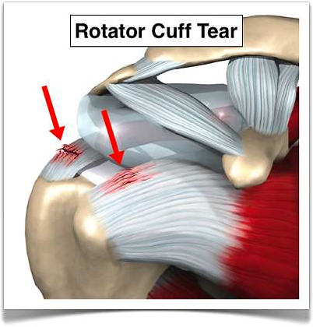
Surgical approach: The rotator cuff naturally has low blood supply. The hope is that if the surgeon sews the torn segment back together, it will heal.
The challenge: Too often, the rotator cuff does not heal due to the poor blood supply and the lack of stem cells for repair. A 57% rotator cuff repair failure rate was reported by the American Academy of Orthopaedic Surgeons (AAOS) in 2012. Many rotator cuff muscles and tendons tear because they have poor blood supply and fewer stem cells, leading to weak tissue. A sling is often worn by the patient for up to six weeks after surgery, further weakening the tendons and muscles. Similar to other orthopedic surgery, rotator cuff repair involves risk of infection, tissue failure, and cardiovascular events.

The RIT approach: Utilizing ultrasound guidance, the physician injects platelets or stem cells into the affected tissue to jumpstart the healing process. Most often, no brace will be needed during recovery, so atrophy of the muscles is less likely. RIT promises no surgical risk, no slings or braces, and participation in a physical therapy program that is often significantly less painful and more functional overall for the patient. Hyperbaric oxygen therapy accelerates the total healing process by feeding the newly implanted cells and by helping repair and strengthen the torn tendon.

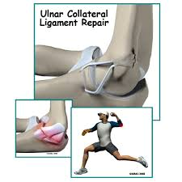
Ulnar Collateral Ligament (UCL) Tears

The surgical approach: This ligament is located in the elbow and is often injured in throwing athletes, such as pitchers. The “Tommy John’s” surgery involves replacing the ligament with a tendon. The challenge: This is often a career-ending injury for many athletes, even after surgery. However, some players go on to play a few more years after losing one to two seasons of play.

The RIT approach: Uses ultrasound stress testing along with Physical Therapy examination to diagnose areas of weakness often missed on an MRI. The physician injects platelets or stem cells into these exact tissues. RIT delivers quicker recovery and quicker return to athletic participation.

Anterior Cruciate Ligament (ACL) Tears

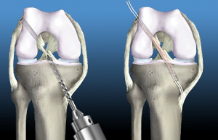
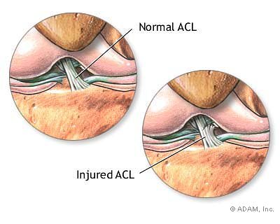
The surgical approach: is to remove a torn ACL and replace with surrogate tendon. It is not an exact copy of the tendon for many reasons. The challenge: is that the substitute ligament goes in at too steep an angle and can never stabilize the knee as well as the original ligament. Clinical expert Mary Ann Porucznik states “The incidence of a second injury to the anterior cruciate ligament (ACL) within the first 12 months after ACL reconstruction and return to sport in a young, active population has been reported to be 15 times greater than a previously uninjured cohort.” Substitute ligaments do not have the proprioception or fine-tuning position sensors of the original tendon. Finally, the rehabilitation time until full play can be six months to one year. Most studies endorse a “no return to athletic activities” restriction for two years, due to the overwhelming reports of re-tear of the surgical graft site and tears of the opposite surgical site ACL.

The RIT approach: Uses the MRI image to map the location of the tear, and then applies real-time ultrasound guidance to inject stem cells and platelet growth factors directly into the tear to heal the area. The rehabilitation time to full activity, including Physical Therapy, can be as little as a few weeks to three months. The hyperbaric oxygen therapy aids in the speedy recovery of not just the ACL, but all tissues of the the body.

Ankle Ligament Tears

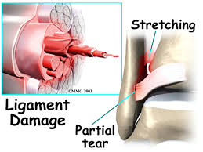
The surgical approach: Although acute ankle sprains are not usually treated surgically, chronically loose ankle ligaments do require surgery for removal. An attempt is made to reroute tendons through small holes drilled into the bone to stabilize the area. The challenge: Much like the more vertical alignment of the ACL repair, the ankle tendons will never have the same ability to protect the joint as well as the native ligaments. In addition, the tendons harvested to replace the ligaments all have a function—there are no spare parts in the body! As a result, the area where the tendons were harvested will never be biomechanically the same.

The RIT approach: Locates the stretched areas using active ultrasound imaging with Physical Therapy stress exams (to place the ligaments under stretch). Platelets or stem cells (depending on the extent of the tears) are then implanted using precise ultrasound guidance into the tears to promote healing of the weak spots. Unlike the long rehabilitation spent on crutches and orthopedic boot of surgery, most RIT patients can return to activities quickly.

Meniscus Tears of the Knee

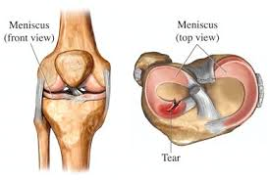
The surgical approach: Removes the torn parts of the partial meniscal tear in the attempt to alleviate pain. The challenge: Important shock-absorbing/guidance of the knee is removed from the body during surgery. Several studies show an increase in arthritis for patients with a history of meniscus removal. Recent studies report little benefit relief from meniscus tear surgery, especially in younger patients not suffering from arthritis. Ironically, the most common orthopedic surgery in the United States is partial meniscectomy.

The RIT approach: First identifies and treats any lax ligaments that may have been injured. Next, the physician carefully maps the location of the tears using ultrasound guidance and injects platelets and/or stem cells (depending on the severity) into the damaged sites. Recovery is faster because there is no surgery and no tissue is removed. Hyperbaric oxygen therapy further reduces inflammation and improves faster healing.

